CS 462 Lab3

Hector A Murillo

1. The ruleset editor tab
2. Rule Conditionals. Eventex seem a little overkill and also not as intuitive since this is my first time with this language. So the drawback is time to figure it out since I’m in a time crunch trying to do the lab…
3. I sent back a couple directives to help me debug in the every clause. I think only one rule ran since there was only one rule in the ruleset at that point.
4. The debugging directives in process_heartbeat plus another directive if the temperature was higher than the threshold_temperature in the find_high_temps rule to give me some feedback to see if I was on the right track. Three directives were returned. 2 rules ran.
5. 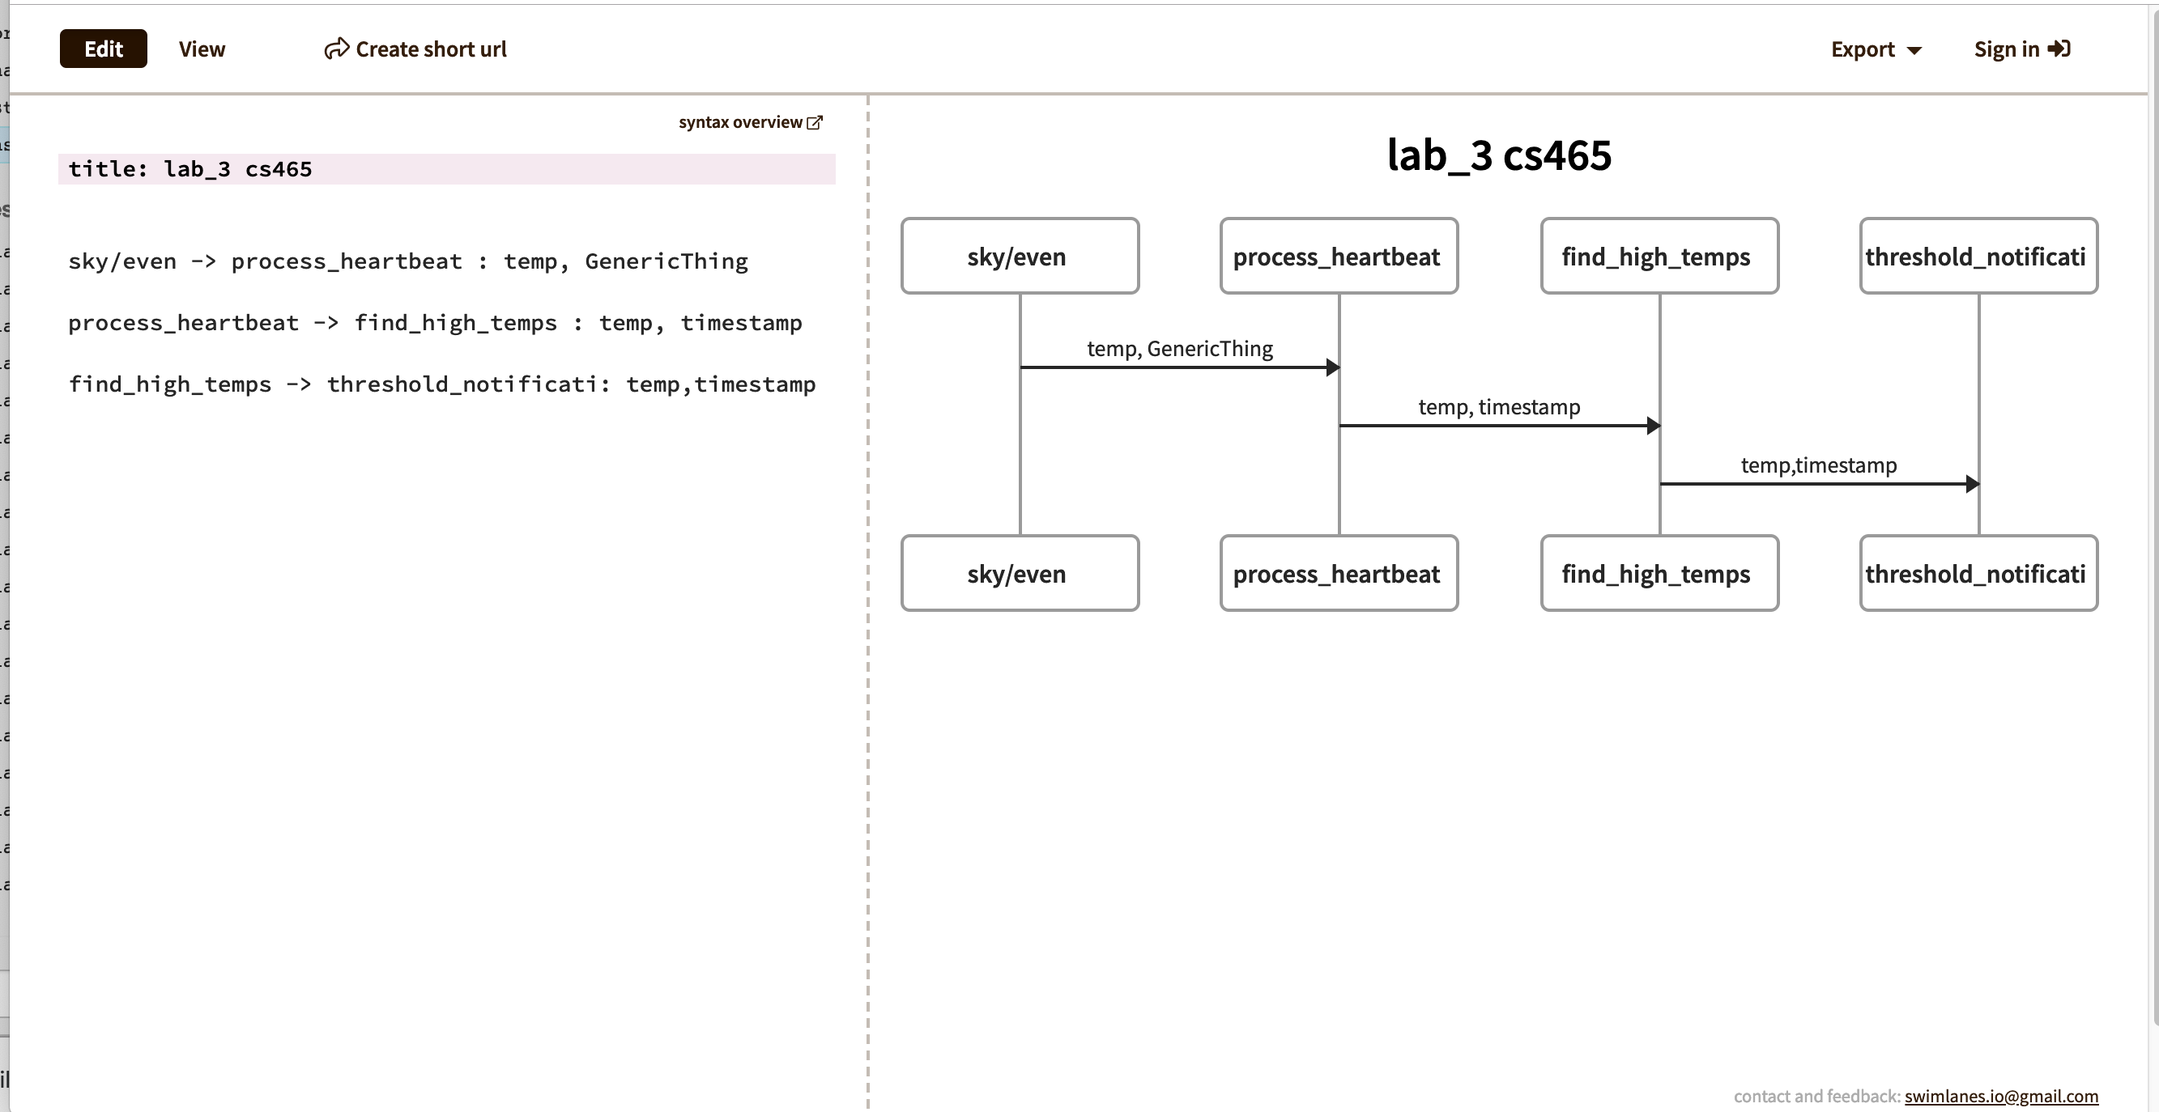
6. Yes. Similarly to how a switch acts as an intermediary between end devices find_high_temps acts that way between process_heartbeat and threshold_notification. It decides if things go to the end point threshold_notification and eventually the user as a text or not.
7. Line 43 of wovyn_base and lines 59-62. Line 43 sends a directive back to postman when I use postman to act as the wovyn device saying there was a threshold violation. Then the call to twilio.send_sms(…) actually sends the text with the correct values in temperature and temperature_threashold